locate command in Linux with Examples

locate command in Linux is used to find the files by name.
There are two most widely used file-searching utilities accessible to users called to find and locate.
The locate utility works better and faster than the find command counterpart because instead of searching the file system when a file search is initiated, it would look through a database.
This database contains bits and parts of files and their corresponding paths on your system.
By default, locate command does not check whether the files found in the database still exist and it never reports files created after the most recent update of the relevant database.

Syntax of `locate` command in Linux

locate [OPTION]... PATTERN...

Exit Status:
This command will exit with status 0 if any specified match is found.
If no match is found or a fatal error is encountered, then it will exit with status 1.

Search a File with Specific Name Using locate Command

locate sample.txt
It will search for sample.txt in a particular directory.
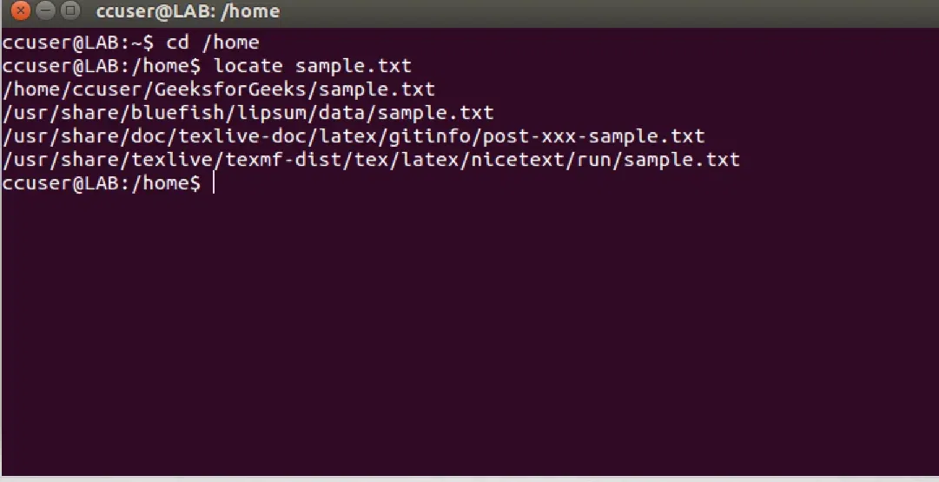

Limit Search Queries to a Specific Number Using locate Command

locate "*.html" -n 20
It will show 20 results for the searching of file ending with .html.
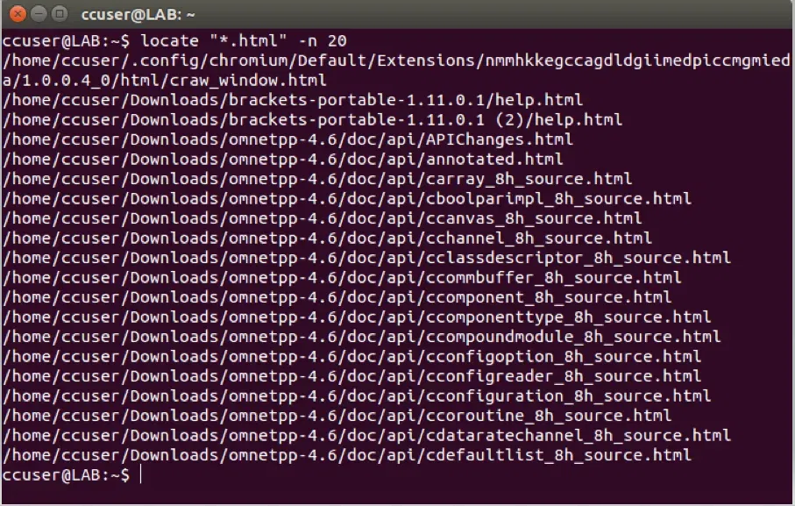

Display The Number of Matching Entries Using locate Command

locate -c [.txt]*
It will count files ending with .txt.

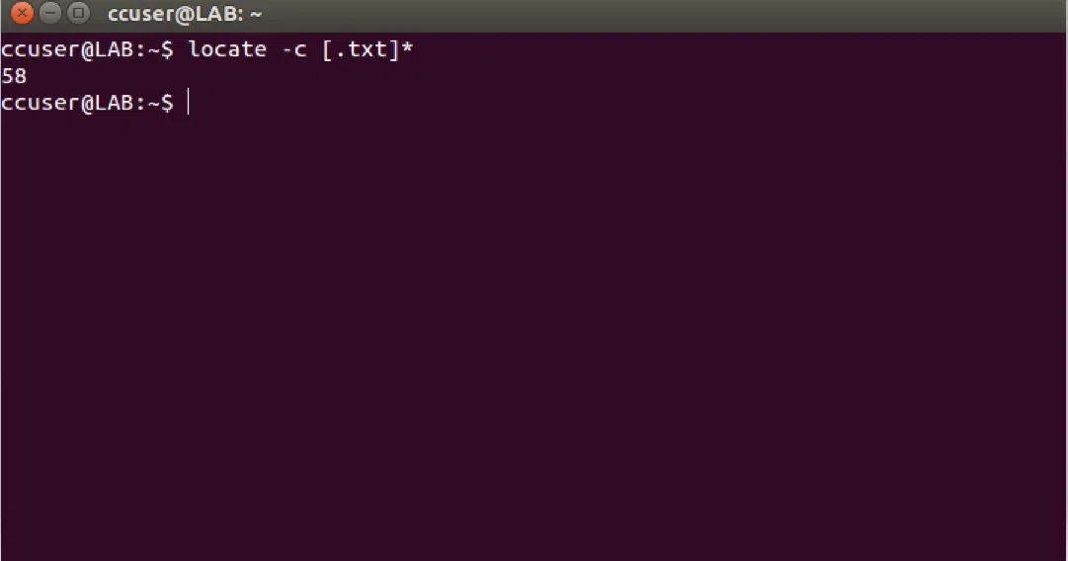

Ignore Case Sensitive Locate Outputs Using locate Command
This command is configured to process queries in a case sensitive manner.
It means SAMPLE.TXT will show a different result than sample.txt.

$ locate -i *SAMPLE.txt*
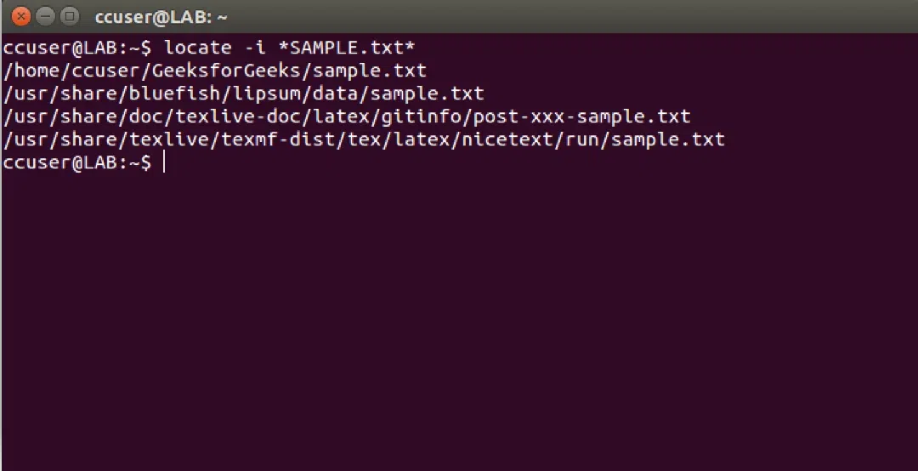

Separate Output Entries Without New Line Using locate Command

locate -i -0 *sample.txt*
Default separator for locate command is the newline (\\n) character.
But if someone wants to use a different separator like the ASCII NULL, then he/she can do so using the -0 command line option.
